LOCHEND & NEW ABBEY CHURCH NEWSLETTER
March 2026

LETTER FROM YOUR MINISTER
“Peace be with you!” These were the first words of the risen Jesus to his disciples on the evening of Easter. And this is the first time in the New Testament that we hear him addressing them in this way. That is remarkable, because “Peace be with you” was – and still is – the traditional Jewish salutation. Clearly, the peace Jesus proclaims is intimately connected to his death and resurrection. Peace is the great gift of Easter.
We may think that the world, in its current state, needs peace more than ever. Yet we should not forget that the peace of Christ is not the peace the world gives (John 14:27). Jesus did not come to make this world a friendlier or kinder place. He came to make this world new. In his death and resurrection, Jesus has overcome the world as we know it, and the new creation has begun.
The word for peace here is the Greek equivalent of the Hebrew shalom. In the Bible, the concept of shalom goes far beyond political stability or the mere absence of conflict; it signifies complete wholeness, soundness, health, safety, and prosperity. It describes a state of well-being that reflects God’s original intention for creation – to live in harmony with its Creator and with one another. This may sound like a beautiful dream, but through Jesus’ death and resurrection, this dream has become reality. Peace is the lived experience of God’s love.
The light of God’s love reaches even into the darkest places. While the disciples hid behind locked doors out of fear, Jesus suddenly stood among them and said, “Peace be with you. As the Father has sent me, so I send you” (John 20:21).
The peace Jesus gives is contagious. He shares his peace so that we may share it with others, because his peace always embraces the whole creation. There can be no true peace while others suffer. Yet in his resurrection, Jesus brings an end to all suffering. When we share his peace, we proclaim the new creation – where there is no more death, no more mourning, no more crying or pain.
When Jesus appeared to his disciples on Easter, he also spoke of the forgiveness of sins. Although humanity was responsible for the death of his Son, he nevertheless forgave us, embracing us with his love. That is the power of his peace. In the same way, we are called to forgive others – even our enemies – and to see them with God’s eyes. “Forgiveness” essentially means letting go of the past and becoming completely open to God’s presence here and now. And when we do, we see everything in a new light – the light of Easter morning.
Happy Easter! Peace be with you!
Yours,
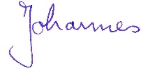

11 Laurieknowe, Dumfries DG2 7AH
tel: 01387 257238
email: jwildner@churchofscotland.org.uk

KIRK SESSION NEWS
Our new Beadle
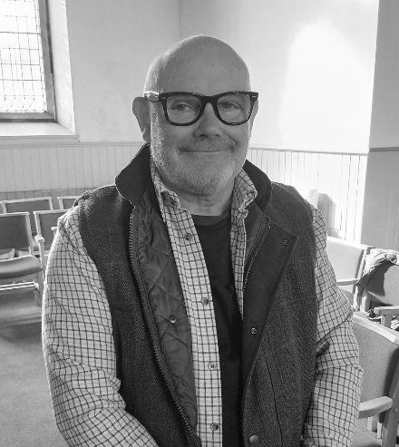
We are very pleased to welcome Glen Barber as our new Beadle. Glen lives in New Abbey and introduces himself:
I was born in Manchester and then moved to a village called Lymm, in Cheshire, where I attended Lymm Parish Church. I have always been a committed Christan and tried to follow the Word of the Lord.
As a young man, I trained as a mechanical engineer and worked all my life in that trade. Since retiring, Ii have been blessed with the extra time to spend with my family, especially my two wonderful grandchildren. Watching them grow and now being able to be part of their everyday life has been such a blessing.
I look forward to serving the church and people for years to come. l am especially grateful to the good people of New Abbey church for appointing me as beadle and being surrounded by like-minded friends.
Mission Partner
Our mission partner, Gary Brough, is returning to Scotland to take up a position of Director of Programmes with the Scottish Bible Society. There may be an opportunity to hear Gary talk about his work in Malawi when he visits Presbytery before he takes up his new position. Details to be confirmed.
Retiring offering
At the Christmas Eve service, the retiring offering raised £180 for Moffat Mountain Rescue.
Stamp Collecting
Thank you to everyone who has collected stamps for the World Mission Stamp appeal over the years. This quote is from the Church of Scotland website: ‘It has been a pivotal part of World Mission Council, collecting much needed money for projects from Partner Churches around the world simply by collecting used stamps.’
From 1995 to 2024 an amazing total of £96,459.67 has been raised for projects such as the HIV programme and Mount Olivet Boys' home in Jamaica & Cayman Islands, to name but a couple.
Food Bank
We still collect non-perishables, foodstuffs and groceries for First Base food bank. Dry goods, breakfast cereals, tins, long life milk, toilet rolls and other toiletries and pet food are all welcome. They can be placed in the box at the back of the church. First Base has now moved premises to share a building with Independent Living Support in George Street Meuse in Dumfries.
Service at Beeswing
On 22nd March our Sunday service will be held in Beeswing Village Hall at the usual time of 9.30am. There will be no service in New Abbey on that Sunday.
Lent Study group
Rev Johannes is leading a Lent Study group on Wednesday afternoons in New Abbey church at 2pm. These will run every Wednesday until 1st April. The subject is the Lord’s Prayer.
Christian Aid Lent lunches
These popular soup-and-roll lunches are held every Friday during Lent in St John’s church, Dumfries. See Eleanor Kinghorn’s Christian Aid report in this newsletter for more details.
Easter
- Maundy Thursday - 2nd April
There will be a Maundy Thursday meal and Communion in New Abbey church at 7pm led by the New Abbey worship team and Maxwelltown West praise group. Bring some sandwiches etc. for your supper to be shared around.
- Good Friday - 3rd April
There will be a service on Good Friday at 3pm in Maxwelltown West church.
- Easter Sunday – 5th April
Easter Day service in New Abbey church at the usual time of 9.30am.
Catherine Lye - Joint Session Clerk

NEW ABBEY GUILD
December - Homelessness
At the end of our December newsletter, I wrote that we were anticipating hearing about homelessness in Dumfries and Galloway from Sarah Marshall, a church member who works in this area for the local council; and so, we did.
Scottish government law binds each local council to provide accommodation for any person presenting themselves as homeless. The availability of emergency and longer-term accommodation in the region needs to be monitored, but the council’s primary aim is to have an action plan whose simplest solution is to intervene and help before someone becomes homeless.
General breakdowns in family relationships and, specifically, young single males having to leave home because of the breakdown in their relationships are two of the most common causes of homelessness. In all cases, a multi-agency approach is viewed as being the most effective way of tackling the crisis.
Our December meeting was our Christmas lunch in the Abbey Cottage Tea room where we were able to relax and enjoy their usual varied festive menu.
January - SHAX
When we reconvened in January, our very interesting follow-up to Sarah Marshall’s talk came through a team from SHAX, who are based on the Crichton Estate. They gave us a very comprehensive overview of their extensive work.
A charitable organisation, their work as a social enterprise is dedicated to alleviating poverty and homelessness by providing essential items and support services. Their objective is to foster community engagement through volunteering and work placements, incorporating training and life skills including those which can lead to employment.
They are dedicated to recycling everything possible, even mattresses, which can now be sanitised and cleaned ready to be used again, thus preventing loads of items going into landfill. This allows them to then provide starter packs of essential goods for those in need, and those who are homeless. Recipients can then create a ‘home’ with their self-respect and dignity intact.
The message is:
Throw NOTHING away, not even your old mattresses. Go to them first. They can clean and re-purpose everything!
SHAX will shortly leave the Crichton Estate as they move into new premises in Marchmount, which are currently being refurbished.
February – Mental health
Our February meeting welcomed two very familiar faces who didn’t even have to travel far to reach us. We were delighted to be able to hear from Rachel and Richard Allen about their respective past lives as chaplains working in the field of mental health.
It was interesting and encouraging to hear how far the focus of mental health has changed from the world I grew up in. The birth of the NHS in 1948 recognised the need for spiritual care which, until then, had been in the purlieu of local ministers who visited the mentally ill in large institutions in large Victorian buildings, which often happened to have very good chapels!
Attitudes began to change as more psychological insights, and other therapies became available and medication improved. Spiritual care was heavily influenced by these, support for staff in addition to patients, their families and carers, fostered more inclusion, and it became clear that pastoral and spiritual care were bound together.
Touching anecdotes about patients’ reactions brought the value of these approaches very vividly to life and it was clear to see why both Rachel and Richard both found their work so rewarding.
March – Daffodil Tea
We will be finishing off our Guild meetings in March when, instead of a speaker, we will celebrate the advent of Spring with our Daffodil Tea. This year, we shall be in the larger room of the New Abbey Village Hall from 2 until 4pm on SATURDAY MARCH 28th. Look out for our poster and do prompt all your friends to join us! No price rise this year - £5 per adult and £2 per child.
Glennys Ardin - Convenor


CHRISTIAN AID
Are you aware that, every year, the Scottish Government allocates £1million to the Humanitarian Emergency Fund (HEF)? Any money that we receive is used to support our partners working on the ground with communities facing a whole range of issues, so the money enables communities to survive when yet another disaster befalls them. In the last year, as a member of the HEF panel, Christian Aid has received £125k to help with on-going work in Malawi, Zimbabwe, South Sudan…………………the list goes on.
Malawi (1)
In Malawi, £150,000 HEF funding is boosting food security and resilience. It supports communities who've been impacted by an on-going food crisis, a result of prolonged dry spells, with the El Nino weather system becoming more extreme due to climate change. Last year, the President of Malawi declared a national emergency because of this extreme weather. As if that wasn’t enough, maize crops, a staple of the country’s diet, have been decimated by invasions of ‘armyworms’.
Zimbabwe (2)

The Zimbabwe Council of Churches was able to use the £175,000 HEF funding from the Scottish Government towards an emergency drought response project. They distributed vouchers which can be exchanged for essential food items. Alongside such food relief, the project has also sought to reduce gender-based violence in the community by improving access to information and support services. Finally, another important element of the project, which has benefitted the whole community, has been the repair of water boreholes. Three projects in one – a great use of the funding!
Sudan (3) & South Sudan (4)
There are many truly heart-rending stories from Sudan and South Sudan, where there is no escape from violence and the atrocities of war. Soldiers kill people indiscriminately in front of their families and people must flee for their lives. Even when they reach what they consider to be a safe haven, the violence seems to follow them and they have to escape again. Nobody is safe. Nowhere is safe.
Kenya (5)
On a more positive note, in Kenya, through our partner organisation Beacon of Hope, we are providing materials and training for Urban Farming. Through this, people are able to grow their own food, which firstly provides nourishing meals for their own families, and secondly allows them a small income by selling any surplus.
In other words, in this country which is experiencing an economic crisis created by climate change, and where more than 33% of the inhabitants are deemed to be malnourished, those trained are able to offset the problems of food insecurity and malnourishment, by learning how to be self-sufficient.
1
6
5
4
3
2
Ethiopia (6)
One of the countries most vulnerable to the impacts of climate change, in recent years Ethiopia has seen a devastating cycle of severe drought and heavy rains, pushing vulnerable communities to their limit. It has meant homes, livelihoods, critical infrastructure and livestock have been destroyed, impacting mental health and increasing a sense of hopelessness as communities and individuals are bombarded by a raft of humanitarian challenges.
Christian Aid is one of four international charities that has been awarded £250,000 by the Scottish Government (so a total of £1m) to address the impacts in Dasenech, South Omo in southern Ethiopia.
By listening to local communities, the Scottish Government identified the greatest needs, and through local partners, Christian Aid is carrying out repairs to damaged infrastructure like boreholes, re-training and job creation projects, much needed psychosocial support for traumatised communities, and a veterinary programme to boost the health of livestock.
Afghanistan
Around half the population, or 23 million people, in this landlocked country requires humanitarian assistance, to cope with conflict, economic collapse, hunger, malnutrition, weak public services and climate shocks. The Head of Christian Aid Scotland, Val Brown, observes:
“The Scottish Government funding allowed us to scale up our response [to the most recent earthquake] and reach those in more remote locations, who may otherwise have been forgotten. Our local partner says they were able to support families, including 93 women-headed households, who’ve lost their home and all their possessions. The cash grants allowed them to meet their immediate needs, as they start rebuilding their lives.”
Ukraine
Christian Aid has been awarded £250,000 from the Scottish Government’s Humanitarian Emergency Fund and works with Blythswood Care to deliver what is necessary, through local partner Heritage Ukraine. The project in Ukraine will allow people to plant vegetable seeds this Spring, fund repairs to homes damaged by missile strikes and help to rebuild water wells in 15 villages in Kherson and Mykolaiv Oblasts. Restoring food and water supplies were priority needs identified by the communities themselves.
Christian Aid’s mission
‘Man’s inhumanity to man’ as Burns so succinctly expressed it, has been the cause of much of the suffering experienced by people through unnecessary conflict due to irresponsible political leaders. This in turn has led to so many people being displaced, no longer having a home to return to and fleeing for their very lives to other countries all over the world, including ours.
If you wish to know more details about the work of Christian Aid, please visit the website:
https://www.christianaid.org.uk/
You will find ways of donating to this worthy cause and the opportunity to sign a petition to the British Government to do more to help the most vulnerable in this world. Alternatively, you can collect an Emergency envelope in church to pop your money in and return to church.
No donation is too little. No life is too insignificant.
Eleanor Kinghorn
CHRISTIAN AID ANNUAL PLANT SALE
Each year, Eleanor holds a Spring Plant Sale to raise funds for those parts of the world where poverty, war and natural disaster has led Christian Aid to become involved.
This year the Spring Sale will be held on
SATURDAY 6TH JUNE - 10.00 to 13.00
at the Village Hall.
Last year, we set the tables up, close to the entrance gate, so people could load their cars as they bought vast quantities of beautiful, quality plants (am I selling this too strongly).
This year, because Eleanor has an array of commitments, the editor is taking the lead on this sale. Last year, he was the apprentice and it seems he has been ‘hired’ not ‘fired’.
So, please, if you have green fingers and feel like donating plants that we can sell to raise funds, either drop them round to Kindar Coach House, next to the church, or let me know (see page 10) and I will pick them up from you.
But, most of all, come and say hello and spend your money on 6th June to help alleviate the scourge of absolute poverty.
Richard

NEW ABBEY 65 CLUB
Plans have been made for a club programme during the spring and summer. Both events are open, and everyone will be welcome.
Tuesday 14th April 14th at 7.00pm
In New Abbey Village Hall, Ian Anderson from Dumfries will give an illustrated talk about his voluntary work with the International Fire and Rescue Service.
Tuesday 19th May
This year, our outing will visit New Lanark. It will be an all-day trip.
Christine Hutton
NEW ABBEY CURLING CLUB
After a relatively quiet time for curling over the festive period, 2026 started with a bang for New Abbey Curling Club, January saw the conclusion of the Grierson medal competition and the start of the Johnstone Trophy where vice-skips lead the teams. Always competitive, it brings a different approach to the games and often unexpected outcomes. The winning teams from both events will be awarded at the end of season social evening.
During January, club members also played in the return match of the Halliday Trophy where Dumfries & Stewartry clubs play Lockerbie. For the first time in a very long time, the result at the end of the 2nd leg in Dumfries was a tie. As 2025 winners, Lockerbie retained the trophy.
In late January, the Scottish Curling Masters event took place at Greenacres in Renfrewshire and as part of Team Craig, club member Margaret Carruthers reached the final. They were unfortunately pipped at the post by the opposition, but what a great achievement to reach the final.
February was a busy time for local Dumfries and Galloway athletes, Grant Hardie, Bobby Lammie and Hammy McMillan. They had curlers and non-curlers on the edge of our seats as they played brilliantly to get to the Olympic Curling men’s final in Cortina. Whilst not winning the medal they wanted, they were awarded with a hard-earned and well-deserved silver medal.
In addition, Sophie Jackson and Fay Henderson - from Holywood and Dumfries respectively - were members of the GB Olympic women’s team who narrowly missed out on a semi-final place after the round robin matches.
February also saw the Scottish Curling championships return to Dumfries. Club member Katie Archibald participated in the event which eventually saw Ross Whyte’s team win the men’s final and Fay Henderson’s team win the women’s event. Both these teams will now represent Scotland at the forthcoming World Championships in the USA.
In March club members Caroline Donaldson, Emily Muir and Kate Thomson qualified to curl at the Henderson Bishop Finals in Kinross. Emily skipped Dumfries 2 but, despite playing well, did not manage to gain a place in the play-offs. Caroline, as vice-skip of Dumfries 1 played exceptionally well. However, they were narrowly beaten in the semi-finals by the ultimate winners of the event, Stranraer.
As we wind up the 2025/26 season for the club, it’s time to celebrate and reflect on the successes as well as commiserate over the ‘what might have been” moments from the year. This is why the presentation of awards at the social evening is so important. It is the one night where, you don’t need gloves and a body warmer, the floor isn’t scarily slippy, no-one needs to hurtle an 18kg (40lb) piece of granite up the ice and most importantly no-one shouts “SWEEP” persistently at the top of their voice – well I hope they won’t!
Whilst this season is ending it will not be long till 2026/27 starts. Perhaps the Olympic curling competition has grabbed your attention, or at the very least piqued your interest. If it has, we would be delighted if you would consider joining our club and try curling.
If you are interested or just want more information, please contact Ross at:
newabbeycurlingclub@outlook.com
and we will get in touch with you.
Kate Thomson - Club President
New Abbey Curling Club
The parish of Lochend & New Abbey covers the villages of Beeswing and New Abbey and pretty much everything in between. For reasons that are not necessarily obvious, there tends to be a focus on New Abbey. Perhaps that is because the church building continues to operate as a place of worship whereas the church is Beeswing has been converted into living accommodation, sadly without anyone inhabiting it.
To balance things up a little, this issue’s spotlight focuses its beam on Loch Arthur; not the farm shop or café, but the intentional community that underpins them. Dave Mitchell, one of the earliest members, and still very active within the Community, describes who and what Loch Arthur Community is.
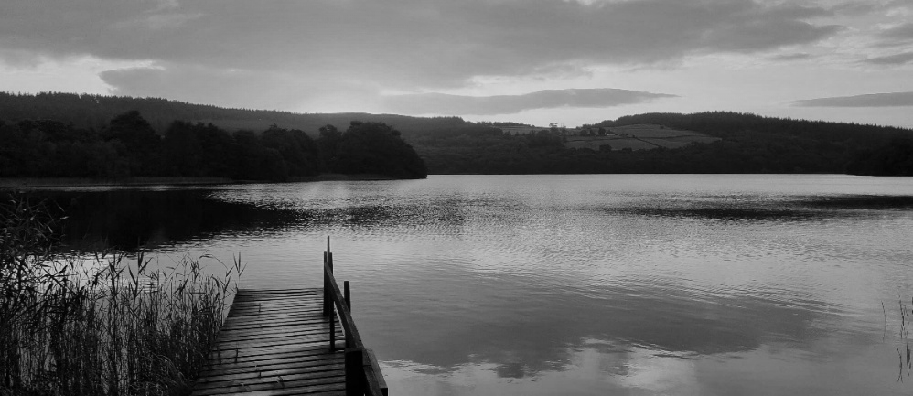

When I’m asked what Loch Arthur Community does, I tend to answer very straightforwardly that we live together, work together and create community together. However, as is the way with the world, life seems to have become much more complex as the Community has grown. But I will come to that later; first a little bit of history.
SPOTLIGHT ON
LOCH ARTHUR COMMUNITY
Loch Arthur is a Camphill Community and by now one of 120 communities in the Camphill Movement spread throughout the world. Camphill began with a group of mainly Jewish refugees who were able to flee Austria in the late 1930’s as the Nazi regime took control. They were led by a charismatic paediatrician, Dr Karl König, and one way or another found their way to Aberdeenshire where they were eventually offered Camphill Estate by the Macmillan publishing family to start a school and to continue their work with children who lived with disabilities.
The beauty that is Loch Arthur
It was König’s view that every human being possessed a healthy ‘inner personality’ that was independent of their outer characteristics, which might include developmental or mental disability. The role of the school was to recognise, nurture and educate this essential self.
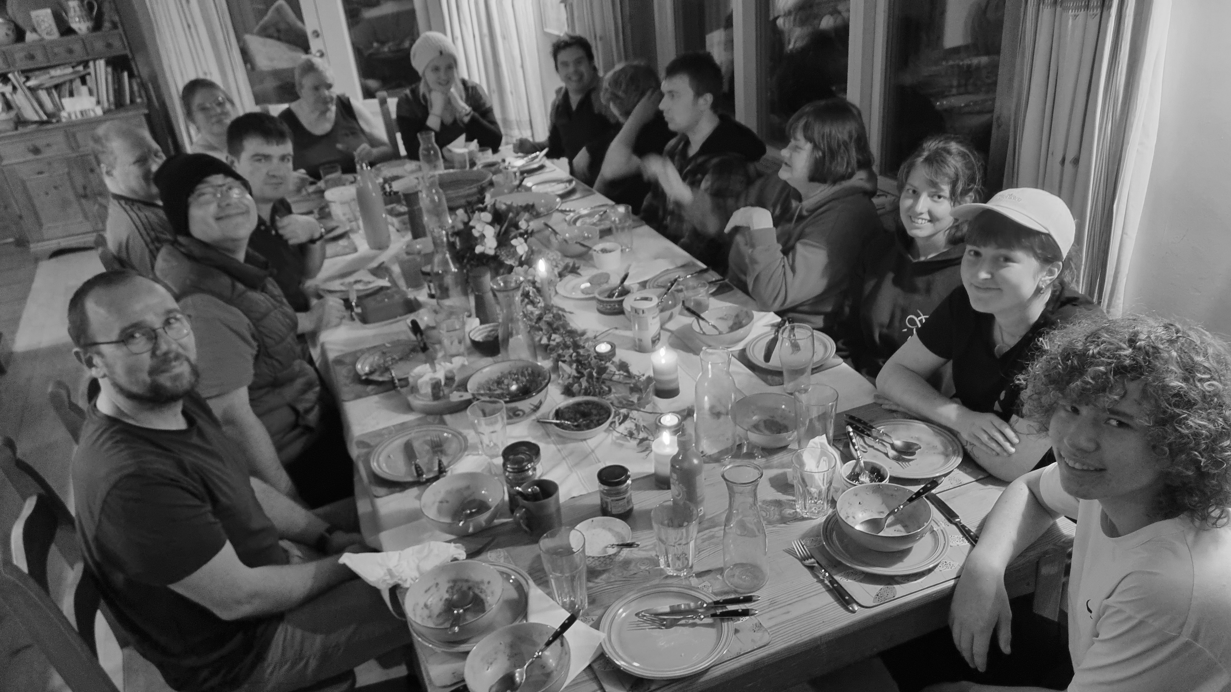
Many young people, initially from war torn Europe came to join this work, and part of their mission was to create community ‘out of the ashes’ that would welcome anyone who wished to share in its purpose. From this seed, Camphill became an international movement as people responded to requests to create new communities. Whilst the first Camphill Communities were schools, the need for training centres for young people and adult communities soon followed. Each Community was autonomous but shared a common ethos, common customs and common practices, largely based on the Christian year. Central to the ethos was that the co-workers were non-salaried and lived and worked alongside the people that they were supporting, their personal costs being met according to their need - which would naturally vary - instead of their role. The communities were also non-hierarchal, managed through consensus decision-making.
Mealtime at Laverock, one of the seven shared houses
In the early 1980’s, the Camphill Communities in Scotland decided to look for somewhere that could take some of the people that had graduated through the Camphill Schools and training centres, but who were unable to get a place in one of the existing adult communities. The brief was to seek a property of about 100 acres, located in the central belt. The mission was to create a community that could take people with complex needs and to run a small production farm, which could supply the other communities in Scotland.
In 1984, the 540-acre central portion of the Lotus Estate was purchased for just over £500,000, and a group of intrepid pioneers came down from Aberdeen. Together, they began to work out how to put these aims into practice on this very beautiful (and very large) piece of land, far away from the other Communities it was intended to serve.
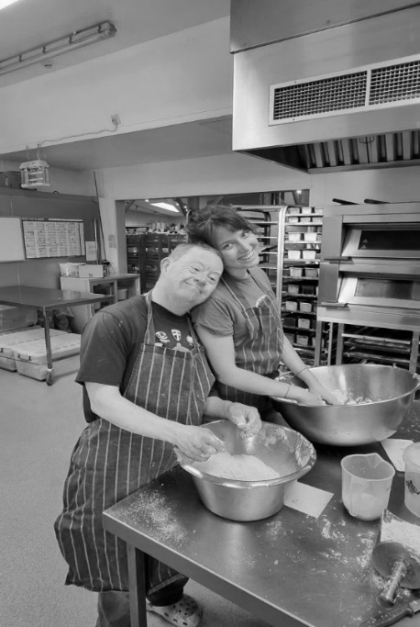
My wife Janet, and I, joined the Community in 1991 and became the 6th family to arrive here. It was very striking to see then what a group of glorious amateurs had already achieved. The farm was already established, and the cheese making had begun in an old byre. There was a small bakery and a weaving workshop, as well as the walled garden growing fruit and vegetables. We were six households, each with a couple and their children, supporting 28 people in total, and working alongside a group of international young people who would volunteer with us for a year. Although very full and very intensive, community life was very straightforward. We shared our lives in our households; each had our work and we came together to celebrate life events and the different festivals. We were blessed to have some very creative people as part of our community and were able to shape a very cohesive and rich social and cultural life.
Sharing bread-making in the bakery
As part of this, we home educated nine of our children until it became clear that they needed to move on to school. We were very fortunate that Mrs Simpson and her amazing team at New Abbey Primary felt able to welcome them into their school community; and so began a wonderfully rich relationship with the wider New Abbey community.
Throughout the years. Loch Arthur has had to be very open to the world around us and to adapt to constant change. What had started out as someone churning butter turned into a creamery in a byre making award winning cheese, that in turn became a purpose-built creamery with a small lean-to shop front that became the large farm shop, which now employs many people from the locality.
We strive to meet the ever-increasing demands of all the regulators that we engage with, and to do all of this without losing the core of what we are – a community of people who want to live and work together. It has always mattered to us that we are not seen as a care provider, but rather as a place that strives to serve the needs of a much wider community.
In recent years we have been severely challenged by Brexit and the decision to end the freedom of movement in Europe. Prior to this, there were many people who wanted to stay longer, grow their relationship with the Community and take on significant responsibility. This ensured that we always had enough people who wanted to live as part of our community. However, now, we need to sustain our co-worker numbers very carefully. This has meant that the 20 or so short-term volunteers who join us each year, and who we rely on, can only now come on a very expensive visa and stay no longer than 12 months.
Along with the increasing regulatory demands which makes living and working together increasingly challenging, this has meant that, in the last few years, we have had to recruit many people in care and support roles through conventional employment; and similarly in the farm shop. In turn, this has created some significant financial questions to overcome for both us and the local authorities who fund placements in the Community. Whilst this process had its challenges, it was clear from the outset that what Loch Arthur has to offer is valued well bey9ond the Community.
In 1991 when Janet and I joined, we were 70 people, 28 of whom had a disability. We had very little employed support and somehow were able to manage to run the houses and all the work areas ourselves. Since then, we have built 2 new houses, renovated 2 more and are still supporting 28 people who live in the Community and 13 more who attend for daytime work opportunities. The administrative demands have grown enormously, together with a farm shop whose expansion has been driven by an unforeseen public enthusiasm for that which we offer.
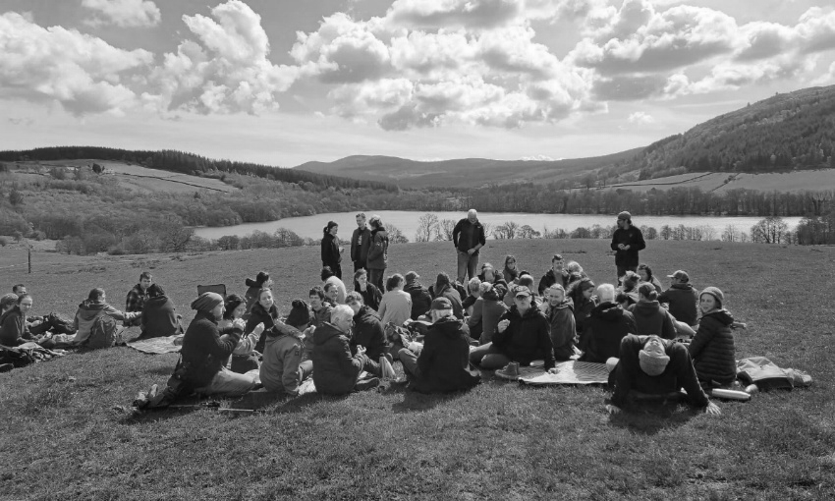
It now means that we employ 80 people who come in during the day. With the 20 long-term volunteers, the 22 short-term volunteers and the 7 children who live in, we have become a much larger extended Community than we would have ever envisaged. We now describe our ‘staffing’ as a ‘hybrid model’- a mixture of live-in volunteers and people who are employed.
So, the big day-to-day challenge as a community, which has quickly grown in numbers, is to find ways to connect with each other. One way is through our social and cultural life, finding ways to come together and celebrate as a community.
Our common space is called Cresset Hall and some of you may know it. A ‘cresset’ is a vessel that holds a light. Our cresset, our hall, is now too small to fit everyone in at any one time. However, its walls are imbued with the essence of so many celebrations that have occurred there. There have been plays, dances, toddler groups, concerts, shared meals, weddings, Christenings and wakes that mark the life of Community.
A Gathering overlooking the Loch
Cresset Hall still houses our weekly Gathering. Each Sunday, someone within the Community takes responsibility to bring some leading thoughts, and surround them with music, poetry and/or stories, to create a coming together that aims to lift us all for the week ahead. This has happened from the beginning and is one of the solid threads that creates the rich tapestry of life at Loch Arthur and holds us all together.
So, with the Sunday Gatherings, and the confidence that has flourished through the first 40 years, here’s to next 40, in the spirit that Karl König and his companions showed when they landed in Scotland and trusted in the future, not knowing where it would lead.
Dave Mitchell – Loch Arthur Community member
As a postscript, the editor knows of at least three people within New Abbey church who are, or have been, connected with the hybrid model to which Dave refers. All have found, or continue to find, the connection a source of joy, love and humour, for which there is no known antidote!


NEW ABBEY SCHOOL
An early Happy Easter from New Abbey Primary. We are enjoying the daffodils and the longer days! I must admit, it’s lovely to be back at New Abbey Primary full-time. Here’s a wee summary of what we’ve been up to since we last ‘spoke’.
In January, we got dressed up for our Burns’ lunch, prepared by our lovely new cook, Trina. We also enjoyed another exciting Career’s Week with very interesting visitors including Glenken and Dee honey producers, a paramedic, local councillor and former teacher Kim Lowe, a Queen of the South football coach, a trades’ lecturer from DG College and local business owner Julie Langlands (also mother to Lyndon Dykes). The children were encouraged to think about where their own skills lie, and which careers might suit them in the future. I was delighted to note that most felt inspired and wanted to try lots of different jobs.
In February, our football team took part in Queen of the South’s Community Plate tournament on the ‘big pitch’ at Palmerston Park. They won 5/6 games, going out on penalties in the semi-final, showing great team spirit throughout. They have more tournaments to come next term.
Our children in P1-4 participated in Gaelic Week, learning words, listening to stories and singing songs. P5-7 enjoyed an authentic Victorian Day as a conclusion to their topic work. Staff and children were dressed accordingly, and lessons were far less interesting than usual with lots of the ‘three Rs’. Their teacher even used the cane on desks and the Dunce Cap loomed in the corner! It was a great experience but the children much preferred school in this time.
During March, P1-4 started a 10-week block of Scottish singing with Ram Tam, funded by the Youth Music Initiative; even more important since schools in Scotland lost specialist teachers a few years ago. We celebrated World Book Day by dressing up as characters from our favourite books and having ‘bookish’ fun throughout the day, all to foster a passion for reading.
Our P6/7 children experienced an exciting range of outdoor activities during our three-day residential trip to the Galloway Activity Centre.
At the time of writing, P5-7 will soon be taking part in Active Schools’ Cross Country Championship at Park Farm. Fingers crossed for dry weather! We will round off the term with an Easter Egg Hunt, kindly organised by our Parent Council.

If you’d like to see more of what we get up to, you can follow us on Facebook. Just search New Abbey Rockstars

Helen Anderson
New Abbey Primary Head Teacher
LOCAL CONTACTS
Johannes Wildner Minister of Max West & New Abbey 01387 257238 jwildner@churchofscotland.org.uk
Catherine Lye Joint Session Clerk 01387 760232 catherinehowdle@yahoo.co.uk
Lorraine Sweeney New Abbey village hall 07770 910156 newabbeyhall@gmail.com
Richard Allen Newsletter editor 07352 066089 brasell10422@gmail.com

THE VILLAGE HALLS
NEW ABBEY VILLAGE HALL
I can’t believe we’re halfway through March already as I write this. Where has the first quarter of the year gone??
We’ve been a bit quieter with events this year so far but that doesn’t mean there isn’t a lot of planning going on in the background. I can’t tell you anything about it just yet, but what I will tell you is that it’s very exciting. There will be lots of events on in the summer months.
We trialled a superhero club for neurodivergent children in February and this was very popular, with families travelling from as far as Gretna. The kids really enjoyed themselves and the parents spent the time chatting. It was really nice to see. All the children got on so well. We will run this once a month. Keep an eye on the Facebook page for this or, if anyone has any questions, email or call me and I would be happy to discuss it.
Jane continues to run the knit and natter and dominoes through the winter on Mondays and Wednesdays.
If anyone would like to hire the hall, we charge £15 per hour and this gives use of our kitchen, in which we have a cooker, microwave, fridge and a fancy water machine for hot drinks.
Thank you to everyone for your continued support.
Let’s see what 2026 brings. If you have any queries or ideas call or text me on 07770 910 156, or email newabbeyhall@gmail.com
Lorraine Sweeney
BEESWING MEMORIAL HALL & LINDESAY MEMORIAL FIELD
The first meetings of the Hall and Field committees of the New Year were held on 20th January. Hall social events were discussed, and the following events were agreed:
- Saturday 11th April – Quiz Night
- Saturday 9th May – Pub Games Night (dominoes, bowls, card game, etc.)
- Saturday 4th July – BBQ (time to be confirmed)
The doors will open for the two evening events at 7pm (bar from 7pm to 11pm). – always a good atmosphere and a chance to meet with others from Beeswing and district.
There will be further events during the year. Let the committee know if you have any ideas for this or are interested in helping with the organisation of them.
In addition to the noticeboard, information can be found on these Facebook pages:

- Beeswing and Surrounds Community (use the adjacent QR code)

- Beeswing Memorial Hall & Lindesay Memorial Field
If you would like to be on the e-mail circulation list, send a request to beeswinghallandfield@gmail.com
The next committee meetings will take place at 7:30pm on Tuesday 31st March in the Memorial Hall.
There was a Sunday Morning Service in the hall on 22nd March which was well attended – another will be held in the summer (date to be confirmed).
Lucy continues her Yoga classes in the hall on Monday evenings 6pm; contact Lucy on 07 950 702 165 for details.
The hall is available for private hire – contact Melanie Brown for bookings: 07 754 144 608 or Melbrown50@btinternet.com
Richard Lye
EVENTS
March
Wednesday 25 March | 02.00pm | Lent Study Group | New Abbey church
Saturday 28 March | 03.00pm | Guild Daffodil Tea | New Abbey village hall
Sunday 29 March | 09.30am | Palm Sunday worship - Rev Liz Mack | New Abbey church
April
Wednesday 01 April | 02.00pm | Lent Study Group | New Abbey church
Thursday 02 April | 07.00pm | Maundy Thursday meal and Communion | New Abbey church
Friday 03 April | 03.00pm | Good Friday service | Max West church
Sunday 05 April | 09.30am | Easter Sunday worship - Rev Johannes Wildner | New Abbey church
Saturday 11 April | 07.00pm | Quiz Night | Beeswing Memorial Hall
Sunday 12 April | 09.30am | Morning worship - Rev Johannes Wildner | New Abbey church
Tuesday 14 April | 07.00pm | 65 Club - International Fire and Rescue Service | New Abbey village hall
Sunday 19 April | 09.30am | Morning worship - Rev Johannes Wildner | New Abbey church
Sunday 26 April | 09.30am | Morning worship - Rev Johannes Wildner | New Abbey church
May
Sunday 03 May | 09.30am | Morning worship - Rev Johannes Wildner | New Abbey church
Saturday 09 May | 07.00pm | Pub Games Night | Beeswing Memorial Hall
Sunday 10 May | 09.30am | Morning worship - Rev Johannes Wildner | New Abbey church
Sunday 17 May | 09.30am | Morning worship - Rev Johannes Wildner | New Abbey church
Tuesday 19 May | All day | 65 Club outing to New Lanark
Sunday 24 May | 09.30am | Morning worship - Rev Johannes Wildner | New Abbey church
Sunday 31 May | 09.30am | Morning worship - Rev Johannes Wildner | New Abbey church
June
Saturday 06 June | 10.00am | Christian Aid plant sale | New Abbey village hall
Sunday 07 June | 09.30am | Morning worship | New Abbey church
Sunday 14 June | 09.30am | Morning worship | New Abbey church
Sunday 21 June | 09.30am | Morning worship | New Abbey church
Sunday 28 June | 09.30am | Morning worship | New Abbey church

Maxwelltown West & New Abbey Church of Scotland: Scottish Charity No. SC015925
Christian Aid Scottish Charity No. SC039150
New Abbey Village Hall: Scottish Charity No. SCO50057

‘Loss and damage is a term used in UN climate talks to refer to the consequences of climate change that go beyond what people can adapt to – eg when extreme droughts turn farmland into dust.
Man was made to Mourn: A Dirge, 1784

