NEW ABBEY GUILD
invites you to a
DAFFODIL TEA
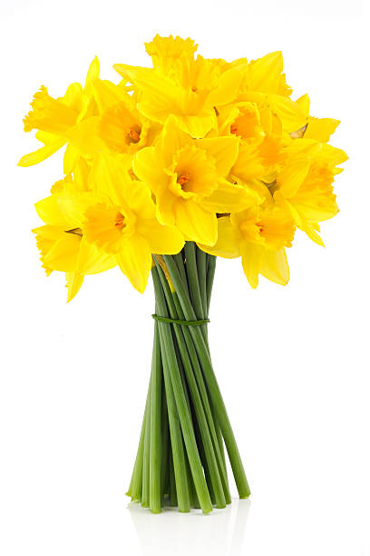

in New Abbey Village Hall
on Saturday 28th March 2pm – 4pm
Tickets at the door
Adults £5 Children £2
Raffle
A WARM WELCOME TO ALL

